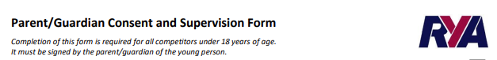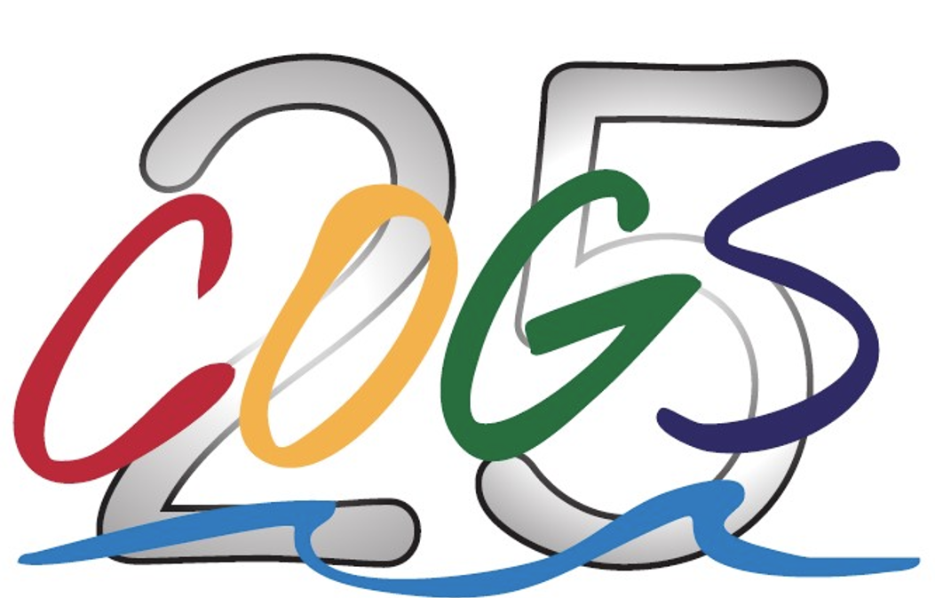

COGS Bay, Coastal and Offshore Races 2026
Season 11th April to 27th September 2026

Competitor: Boat Name:

Applicable Dates: Sail #:
