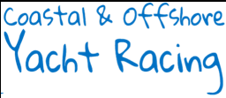

*www.cogsracing.org.uk/*

*email:chairman@cogsracing.org.uk*

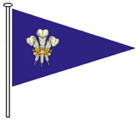

**RCYC Sailing Ltd**

**TRINITY RACE**

**Saturday 23rd to Monday 25th August 2025**

**(an element of the COGS Offshore Series 2025)**

*Organizing Authority: RCYC Sailing Ltd*

*Greenbank, Falmouth, Cornwall, UK*

[*www.royalcornwallyachtclub.org/*](http://www.royalcornwallyachtclub.org/) *email: contact@rcycsailing.org*

**NOTICE OF RACE**

*Abbreviations: [DP] – Rules for which the penalties are at the discretion of the protest committee.*

*[NP] - means that a boat may not protest another boat for breaking that rule. This changes RRS 60.1.*

# RULES

1.1 The race will be governed by the rules as defined in *The Racing Rules of Sailing* (RRS).

1.2 The sailing instructions will replace rules of RRS part 2 by the right of way rules of the International Rules for the Prevention of Collisions at Sea (IRPCAS) for parts of the race.

1.3 World Sailing Offshore Special Regs (OSR) 2024-25 Cat 3 with liferaft will apply.

1.4 Local regulations will apply concerning safe navigation in close proximity of large vessels restricted in their ability to manoeuvre, and dive vessels. Full details will be given in the S.I.

1.5 The sailing instructions may change other rules.

1.6 RRS 63.5 (c) is changed to permit a rule in the Sailing Instructions to take precedence over a rule in the Notice of Race.

# SAILING INSTRUCTIONS

Sailing instructions may be downloaded from the RCYC website – [www.royalcornwallyachtclub.org](http://www.royalcornwallyachtclub.org)/On the Water/Racing Events/COGS Racing Events before midday on Wednesday 20th August.

# COMMUNICATION

* 1. The online official noticeboard is located at [www.cogsracing.org.uk](http://www.cogsracing.org.uk)

There will be no physical noticeboard.

* 1. Competitors will be alerted by the COGS WhatsApp group to any changes or new notices being posted. The race committee may also use WhatsApp to make other courtesy announcements concerning the event. Boats should register at least one device to receive WhatsApp.
  2. On the water, the race committee may make courtesy and safety broadcasts to competitors on VHF radio and the COGS WhatsApp group. The VHF channel(s) will be stated in the S.I.
  3. [DP] Except in an emergency, from the first warning signal until the end of the race a boat shall not make voice or data transmissions and shall not receive voice or data communication that is not available to all boats.

# ELIGIBILITY AND ENTRY

* 1. The event is open to paid up entrants of COGS with mono-hull boats that:

1. are seaworthy boats (World Sailing Offshore Special Regulations (OSR) 2024-2025 Section 3 (cat 3) with hull length between 7.85m and 18.5m inclusive.
2. are sailed fully crewed or two-handed.
3. have a current and valid IRC primary certificate or short-handed certificate, or Royal Yachting Assoc. AERA Yacht Time Correction System (YTC) certificate, on 22nd Aug 2025. Changes to the rating will not be permitted after this date except as a result of a rating protest or to correct rating office errors.
4. are registered with the [safetrx.rya.org.uk](https://safetrx.rya.org.uk) system (NB boats must **not** submit the race as a SafeTrx journey; it is only necessary for boat details to be held on the SafeTrx database).
   1. All entries shall be submitted on-line at [www.cogsracing.org.uk](http://www.cogsracing.org.uk) prior to Friday 22nd Aug.

4.3 An entry is not complete until:

* the entry fee has been paid in full to COGS.
* a copy of the IRC or YTC certificate has been submitted on-line to COGS at [www.cogsracing.org.uk](http://www.cogsracing.org.uk)
* a crew list has been submitted to the Organising Authority (OA). The crew list shall identify the designated “deputy person-in-charge” should the person-in-charge become incapacitated, and shall contain full emergency shore contact details. The form will be available for download at [www.royalcornwallyachtclub.org](http://www.royalcornwallyachtclub.org/)/On the Water/ Racing Events/COGS Racing Events.
* a parental (or guardian) consent form and declaration has been submitted to COGS (who forward on to the OA) for crew age 18 and under. The form is available for download at [www.cogsracing.org.uk](http://www.cogsracing.org.uk)

# FEES

There will be no fee to the OA.

# CREW LIMITATIONS

IRC rule 22.4 will not apply. There will be no limitations on crew number or weight.

# ADVERTISING

* 1. Boats may be required to display advertising chosen and supplied by COGS.
  2. IRC Rules Part D will not apply.

# QUALIFYING SERIES AND FINAL SERIES – not used

# SCHEDULE

|  |  |  |  |
| --- | --- | --- | --- |
| **Date** | **Activity** | **Time** | **Location** |
| Saturday 23rd Aug | IRC first warning signal | 10:55 BST | Pendennis Headland |
| YTC first warning signal | 11:00 BST | Pendennis Headland |
| Monday 25th Aug | Race time limit | 08:00 BST |  |
| Deadline for submitting finish declarations  on the COGS Chat Whatsapp group. | 10:00 BST |  |
| Prize-giving | tba | tba |

# EQUIPMENT INSPECTION

10.1 Each boat shall be able to produce or verify the existence of a valid IRC or YTC rating certificate.

10.2 Boats may be inspected at any time. The fact that race officials may conduct inspections of a boat does not reduce the responsibilities of each competitor as set out in this NOR.

# CLOTHING & EQUIPMENT – not used

# VENUE

* 1. NOR Addendum A shows the plan of event.

Racing will take place off the south Cornwall coast.

* 1. The race office will be situated at the Royal Cornwall Yacht Club.

# COURSES

* 1. The start area will be in Falmouth harbour off the eastern shore of Pendennis Point.
  2. Courses will be Falmouth, Hand Deeps cardinal, Eddystone, Wolf Rock and back to a finish in Falmouth (or vice versa) and will be detailed in the S.I.

# 14 PENALTY SYSTEM

For all boats RRS 44.1 is changed so that a Two-Turns Penalty is replaced by a One-Turn Penalty.

# SCORING

15.1 RRS Appendix A will apply.

15.2 Series scoring will be in accordance with COGS NOR para 7.

# SUPPORT PERSON VESSELS – not used

# CHARTERED OR LOAN VESSELS – not used

# BERTHING

18.1 In Falmouth:

Visiting boats will need to arrange their own berthing before and after the race. Berthing is available at Port Pendennis marina ([www.portpendennis.com](http://www.portpendennis.com/)), the Falmouth Haven Marina (www.falmouthhaven.co.uk/moorings/introduction/), and Falmouth Marina ([www.premiermarinas.com/pages/falmouth_marina](http://www.premiermarinas.com/pages/falmouth_marina)). Visitors swinging moorings are also available in Falmouth inner harbour ([www.falmouthhaven.co.uk/moorings/introduction/](http://www.falmouthhaven.co.uk/moorings/introduction/)).

# HAUL-OUT RESTRICTIONS – not used

# DIVING EQUIPMENT AND PLASTIC POOLS – not used

# DATA PROTECTION AND MEDIA RIGHTS

* 1. The personal information you provide to the OA will be used to facilitate your participation in the event. If you have agreed to be bound by the RRS and the other rules that govern the event (the rules), the legal basis for processing that personal information is contract. If you are not bound by the rules, the legal basis for processing that personal information is legitimate interest. Your personal information will be stored and used in accordance with the OA’s privacy policy. When required by the rules, personal information may be shared with the RYA, your national authority and/or World Sailing. The results of the events and the outcome of any hearing or appeal may be published.
  2. Competitors and/or their Guardians automatically grant to the organising authority and any party to which they may delegate this right, without payment the right in perpetuity to make, use and show (including via the internet), any motion pictures, still pictures, live, taped or filmed television or any other form of media, of or relating to the event.

# RISK STATEMENT

22.1 Rule 3 of the Racing Rules of Sailing states: “The responsibility for a boat’s decision to participate in a race or to continue racing is hers alone”. Sailing is by its nature an unpredictable sport and therefore inherently involves an element of risk. By taking part in the event, each competitor agrees and acknowledges that:

a) They are aware of the inherent element of risk involved in the sport and accept responsibility for the exposure of themselves, their crew and their boat to such inherent risk whilst taking part in the event;

b) They are responsible for the safety of themselves, their crew, their boat and their other property whether afloat of ashore;

1. They accept responsibility for any injury, damage or loss to the extent caused by their own actions and omissions;
2. Their boat is in good order, equipped to sail in the event and they are fit to participate;
3. The provision of a race management team, and other officials and volunteers by the event organiser does not relieve them of their own responsibilities;
4. The provision of patrol boat cover is limited to such assistance, particularly in extreme weather conditions, as can be practically provided in the circumstances.
5. It is their responsibility to familiarise themselves with any risks specific to this venue or this event drawn to their attention in any rules and information produced for the venue or event and to attend any safety briefing held for the event;
6. They are responsible for ensuring that their boat is equipped and seaworthy so as to be able to face extremes of weather; that there is crew sufficient in number, experience and fitness to withstand such weather; and that the safety equipment is properly maintained, stowed and in date and is familiar to the crew.

# INSURANCE

Each participating boat shall be adequately and suitably insured with valid third-party liability insurance before racing. Competitors will be required to sign a declaration to this effect at registration.

# PRIZES

Prizes will be awarded for 1st to 3rd places in each class (IRC, YTC, IRC 2-handed, YTC 2 handed).

# FURTHER INFORMATION

For further information please visit the RCYC website, contact the main office: Tel: +44 (0)1326 312 126, Fax: +44 (0)1326 211 614 or email: [contact@royalcornwallyachtclub.org](mailto:contact@royalcornwallyachtclub.org)

# NOR Addendum A

**Venue**

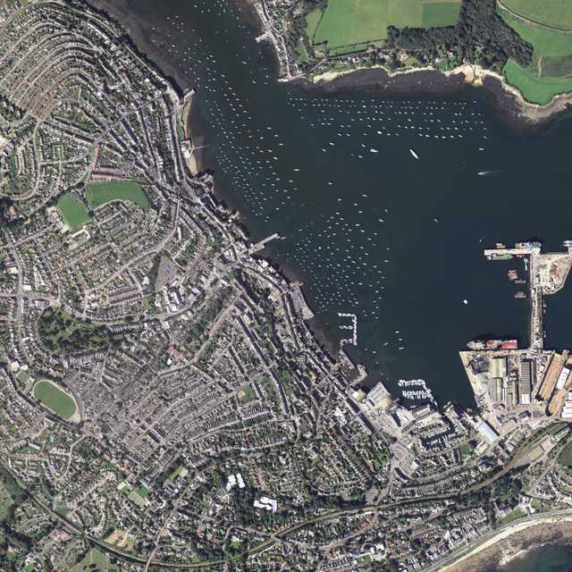

**4**

**3**

**2**

**1**

1 - Royal Cornwall Yacht Club

2 - Port Pendennis marina

3 - Falmouth Yacht Haven

4 - Falmouth Marina