**The**

**Bay Series**

**Sailing Instructions Amendment No 1**

**19 May 2024**

**Paragraph 7.1 (The Course) is altered to read:**

**Will be selected from the numbered list of courses in Appendix A and will depend on wind strength and direction.**

**A Race Officers Choice course may be given if weather conditions dictate that the numbered courses are inappropriate, using the additional marks in Appendix D**

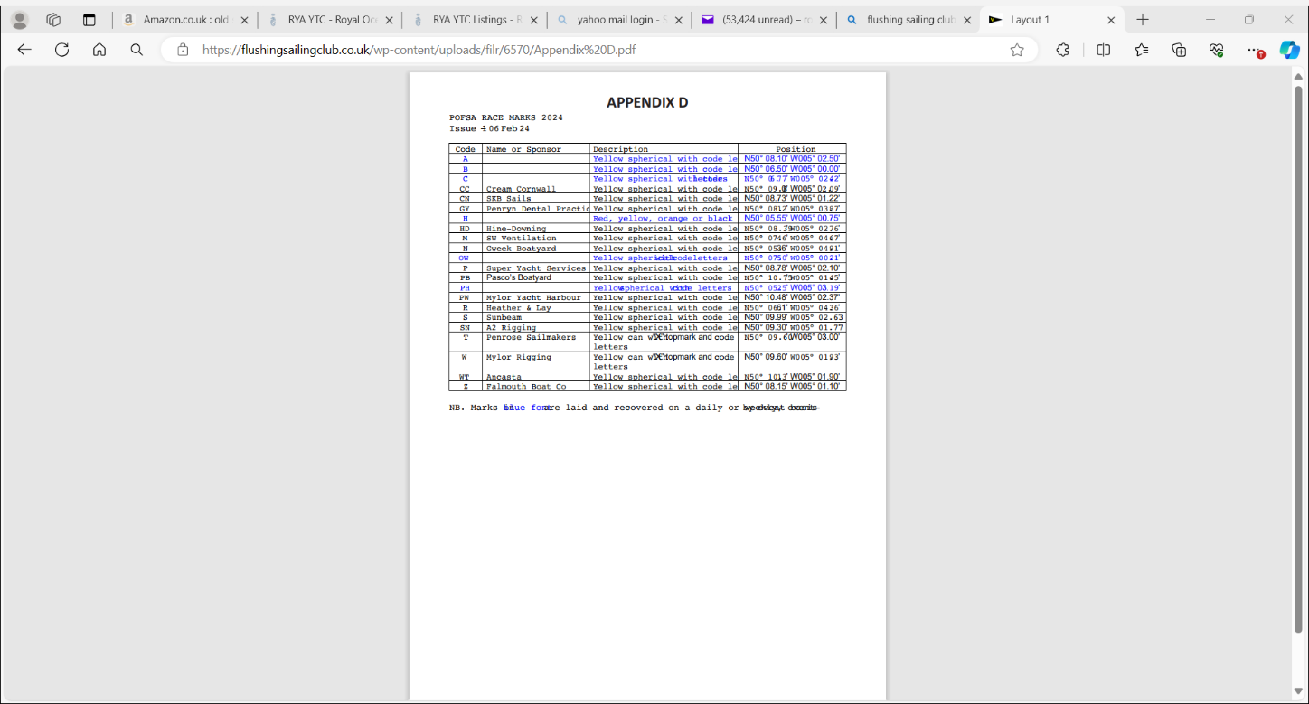

**Paragraph 17. (Crew Lists) is altered to read:**

**All skippers shall confirm sail number and Class entered, and declare number of persons on board via Radio Ch 72 to the Race Officer no later than 20 minutes before the first start. Radio silence must be kept after this time except if called by the Race Committee or in an emergency.**

**A full list of crew racing must be held by a shore based contact for the boat.**

**Skippers are obliged to complete a Google Form for their boat before Noon on the Friday before the race at the following link:**

[**https://forms.gle/bQPj5HaRZHFbvBPb9**](https://forms.gle/bQPj5HaRZHFbvBPb9)

**Supplementary Notice A. is altered to read:**

**The Club bar will be open, and hot pasties available at cost (£3.00 each)**

**Please pre order pasties by WhatsApp or text to Gaye Slater at 07929365855 by Noon on the Thursday before the race.**